WEEK 4
Date: |  | Day: MONDAY |  |  | Strand: All Around Us
 |  |  |  |  | Sub Strand: AIR
Class: KG 2 |  |  | Class Size:
Content Standard:  K2.6.4.1 Demonstrate understanding that air is all around us and it is an important and beneficial natural resource for all living things. |  |  |  | Indicator:  K2.6.4.1.7 classify objects in the environment according to those that have weight and heavy and those without weight and less heavy
Performance Indicator:  - Learners can participate actively in the teacher-read-aloud of the text on air  - Learners can classify objects in the environment according to those that have weight and heavy and those without weight and less heavy |  |  |  |  | Core Competencies:  Communication and collaboration, Critical thinking, Personal Development and Leadership
Keywords: leaves, stones, bottle caps, books, etc
Reference : KG Curriculum P.g. 166-169
Phase/Duration | Learners Activities |  |  |  |  | Resources
PHASE 1: STARTER | Let learners sing a song in relation to the lesson.  1. Did you enjoy the song?  2. What words did you hear in the song?
PHASE 2: NEW LEARNING  CIRCLE TIME | Select several items that have well-defines outlines  Place each item on a separate sheet of paper and draw its outline with a fine felt-tip pen  Gather the outlines in a pile and place the items in a paper bag. Call learners into the room.  Show them the first outline and have them guess the first item. Give them hints if necessary.  After they guess correctly, pull the item out of the bag and place it on the outline!  Repeat for the remaining items. |  |  |  |  | felt-tip pen, sheet of paper
GROUP ACTIVITY 1  (OUTDOOR) | Teacher follows the steps of the KWL strategy instruction in reading aloud the informational text entitled AIR is all around us).  Have learners perform some simple activities showing that air is all around us.  Provide learners with variety of objects picked from the environment and around the school, e.g. leaves, pens, paper, balloons, paper aeroplanes, bottle tops, bottles with water, empty bottles, rocks.  Working in small groups, have learners use non-standardized scales to estimate the weight of these objects and then classify them into two groups, objects that have weight and heavy, and objects that have little weight and less heavy.  Using bottle tops or other countable objects, guide learners to pick and count the number of objects in each category.  Pick the numeral card which matches with the number of objects |  |  |  |  | The big book, crayons, pencils, pictures and videos depicting the uses of air.
PHONICS | Engage learners to sing songs and recite some familiar rhymes that relates to the target sound.  Guide learners to pronounce and write the target sound in the sand tray or exercise books.  Have learners say three or four words that contain the target sound.  Using flash cards, learners read words that contain the target sound.  1. What sound have we learnt today?  2. Which other letter sound do you know?  3. Mention any object in the classroom or home that begins with the target letter sound. |  |  |  |  | Word cards, letter cards.
GROUP ACTIVITY 2  (INDOOR) | Demonstrate to learners by filling two different containers.  E.g. 1 litre bottle, and 500mls bottle with water.  Fill the smaller bottle up to the brim and pour it into the 1 litre bottle. Have learners tell you what they observed.  There is still space in the bigger one which means the bigger bottle holds more water than the smaller one.  The smaller container holds less water than the bigger bottle.  Put learners into groups of four. Give them two different plastic cups.  Let them fill one and pour it into the other one and compare which cup holds more or less water.  Note: This activity should be done outside the classroom  Assessment  Have learners work in pairs. Give them milo tins and milk tins. Ask them to fill the milo tin with water up to the brim and pour it into the milk tin and compare. They should use the expression “holds more than / holds less than” |  |  |  |  | bowls of different capacities, plastic bottles and milk tins
LEARNING CENTER | Engage learners to play freely at the learning centers.  Observe, join in and ask learners questions frequently to guide their play and to support their understanding in what they are learning. |  |  |  |  | Learning center
STORY SHARING | Tell learners a story.  Pause regularly and ask questions to make sure learners are following.  Engage learners to act parts of the story.  1. Was the story interesting?  2. What part of the story did you like?  3. What have you learnt from the story? |  |  |  |  | Word cards, letter cards.
PHASE 3: REFLECTION | Learners share what they have learnt with their peers and class.  Give learners homework to do at home.

Date: |  | Day: TUESDAY |  |  | Strand: All Around Us
 |  |  |  |  | Sub Strand: AIR
Class: KG 2 |  |  | Class Size:
Content Standard:  K2.6.4.1 Demonstrate understanding that air is all around us and it is an important and beneficial natural resource for all living things. |  |  |  | Indicator:  K2.6.4.1.6 prepare and fly kites and other paper aeroplanes outside the classroom
Performance Indicator:  - Learners can blend the letter-sounds learnt so far into syllables, read and write the syllables boldly and legibly in their books.  - Learners can prepare and fly kites and other paper aeroplanes outside the classroom |  |  |  |  | Core Competencies:  Communication and collaboration, Critical thinking, Personal Development and Leadership
Keywords: air, aeroplane, kite
Reference : KG Curriculum P.g. 166-169
Phase/Duration | Learners Activities |  |  |  |  | Resources
PHASE 1: STARTER | Let learners sing a song in relation to the lesson.  1. Did you enjoy the song?  2. What words did you hear in the song?
PHASE 2: NEW LEARNING  CIRCLE TIME | Make a list of several noise-making items familiar to your kids. You might also want to record various sounds on tape before starting the game.  Sit with your child at a table or on the floor in a quiet room and ask him to listen carefully. Blindfold one of them or have him close his eyes so he cannot see what you do.  Make the sound of one of the items on your list.  Ask your learners to guess the item. Give him hints if necessary.  Repeat with the rest of the sounds.
GROUP ACTIVITY 1  (OUTDOOR) | Have learners sing/recite rhyme on air. I am the endless air. I am the air to breathe. Plants, animals and humans use me. Don’t pollute me  Revise letter-sounds learnt so far will learners. Write them on the board and let them sound them. /a/, /b/, /p/, /u/, /v/, /s/.  Guide learners to blend letter-sounds to form one syllable putting together consonant and vowel sounds  E.g. ma, da, fa, ba..  Use the “learners blending process”  Call two learners to the front and give them a consonant and a vowel sounds. Let them hold individual letter card separately and gradually and slowly move towards each other until they stand close to each other and put their letters to read a syllable  E.g. b, a→ba.  Guide learners to practice of this process to help them blend sounds easily e.g. blend the vowel ‘e’ with different consonants. |  |  |  |  | letter cards, word cards
PHONICS | Engage learners to sing songs and recite some familiar rhymes that relates to the target sound.  Guide learners to pronounce and write the target sound in the sand tray or exercise books.  Have learners say three or four words that contain the target sound.  Using flash cards, learners read words that contain the target sound.  1. What sound have we learnt today?  2. Which other letter sound do you know?  3. Mention any object in the classroom or home that begins with the target letter sound. |  |  |  |  | Word cards, letter cards.
GROUP ACTIVITY 2  (INDOOR) | Provide a selection of props (balloon, wigs, twigs, flowers, scarfs, ribbon, hat, etc) and have learners choose one at a time to dance with.  Talk about how each item changes or influences their movement. Extend this by allowing learners to search out and find their own props to dance with. They can dance with a partner while still using their prop.  Have learners work in pairs. Give them sheets of paper to fan themselves.  Let them tell you their experiences. Let them hold their noses for few seconds and tell you their experiences (without air, we cannot breathe).  Have learners tell you other things which need air to move or grow.  If they are unable, tell them that birds aeroplane, kites need air to fly (show some pictures on page 99 of the workbook).  Guide learners to prepare their own kite and paper aeroplanes.  Provide them with ruler. Guide them to measure the lengths and breath of cards or paper. Provide them with tracing thread.  Give them stickers or straws to attach their art works.  Assessment  Take learners outside the classroom to fly their kites or aeroplane.  Let them tell you what made their objects fly? (it is air) “Air is everywhere” |  |  |  |  | Pictures of birds, aeroplane, balloons, kites, chalks, sheets of paper, crayons, pencils
LEARNING CENTER | Engage learners to play freely at the learning centers.  Observe, join in and ask learners questions frequently to guide their play and to support their understanding in what they are learning. |  |  |  |  | Learning center
STORY SHARING | Tell learners a story.  Pause regularly and ask questions to make sure learners are following.  Engage learners to act parts of the story.  1. Was the story interesting?  2. What part of the story did you like?  3. what have you learnt from the story? |  |  |  |  | Word cards, letter cards.
PHASE 3: REFLECTION | Learners share what they have learnt with their peers and class.  Give learners homework to do at home.

Date: |  | Day: WEDNESDAY |  |  | Strand: All Around Us
 |  |  |  |  | Sub Strand: AIR
Class: KG 2 |  |  | Class Size:
Content Standard:  K2.6.4.1 Demonstrate understanding that air is all around us and it is an important and beneficial natural resource for all living things. |  |  |  | Indicator:  K2.6.4.1.1 share their ideas with teacher and peers about the presence and importance of air.
Performance Indicator:  - Learners can share their ideas with teacher and peers about the presence and importance of air.  - Learners can classify objects in the environment according to those that have weight and heavy and those without weight and less heavy |  |  |  |  | Core Competencies:  Communication and collaboration, Critical thinking, Personal Development and Leadership
Keywords: breath, air, blowing
Reference : KG Curriculum P.g. 166-169
Phase/Duration | Learners’ Activities |  |  |  |  | Resources
PHASE 1: STARTER | Let learners sing a song in relation to the lesson.  1. Did you enjoy the song?  2. What words did you hear in the song?
PHASE 2: NEW LEARNING  CIRCLE TIME | Sit at a table with your learners.  Ask her to name a letter of the alphabet  Write the letter in large print in the middle of the paper.  Slide the paper over to her and have her transform the letter into a funny picture of an animal, design, or other object.  Select another letter and repeat.
GROUP ACTIVITY 1  (OUTDOOR) | Sing a song on “Air” with learners.  Have learners sit in a community circle. Let them play “pass the ball”. Learners pass the ball to their friends.  Let everybody hold their nose for some few seconds. Have learners share their experiences with the class  Take learners for a “Nature walk” around the school compound. Ask them to observe the leaves of trees, movement of papers and rubbers on the floor.  Let them tell you what is making the papers scatter on the floor, and the leaves of the tree move. (it is the presence of air)  Divide the class into four groups to perform these activities.  - Group 1: Fill bottles with water and observe the bubbles.  - Group 2: Blow air into balloons and leave them to fly  - Group 3: Fly kites into the air  - Group 4: Tie two ends of cloth around their waist, hold the other two ends and run.  Ask learners to tell you what made these experiments work? (it’s the presence of air). Air is around us. Air is everywhere  Ask them a question: Do animals and fish need air?  Put them into groups of six. They discuss the topic and come out with their findings. (Animals and fish need air).  Assessment  Have learners work in pairs. They mention three living things that need air to live |  |  |  |  | balloons, umbrella, balls, clothes, fish, pictures, crayons, pencils
PHONICS | Engage learners to sing songs and recite some familiar rhymes that relates to the target sound.  Guide learners to pronounce and write the target sound in the sand tray or exercise books.  Have learners say three or four words that contain the target sound.  Using flash cards, learners read words that contain the target sound.  1. What sound have we learnt today?  2. Which other letter sound do you know?  3. Mention any object in the classroom or home that begins with the target letter sound. |  |  |  |  | Word cards, letter cards.
GROUP ACTIVITY 2  (INDOOR) | Display a conversational poster and some concrete materials related to the theme, e.g. balloons, and engage learners in activities that shows air is around us.  E.g. Learners hold their nose for some few seconds, blow into balloons, hold their breath, etc.  Learners share their experiences on the theme.  Take learners for a Nature Walk and challenge them to look at the movement of leaves and for other evidence of Air around us  Centre time: Learners perform different experiments to show presence and importance of air around us and talk about their experiences  1. Fill bottles with water and observe the bubbles,  2. Observe balloons fly, observe trees  3. Prepare and send kites into the air etc.  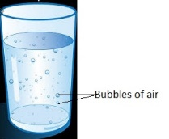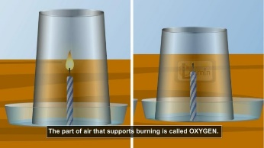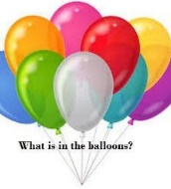  Provide learners with variety of objects picked from the environment and around the school,  e.g. leaves, pens, paper, balloons, paper aeroplanes, bottle tops, bottles with water, empty bottles, rocks.  Working in small groups, have learners use non-standardized scales to estimate the weight of these objects and then classify them into two groups, objects that have weight and heavy, and objects that have little weight and less heavy.  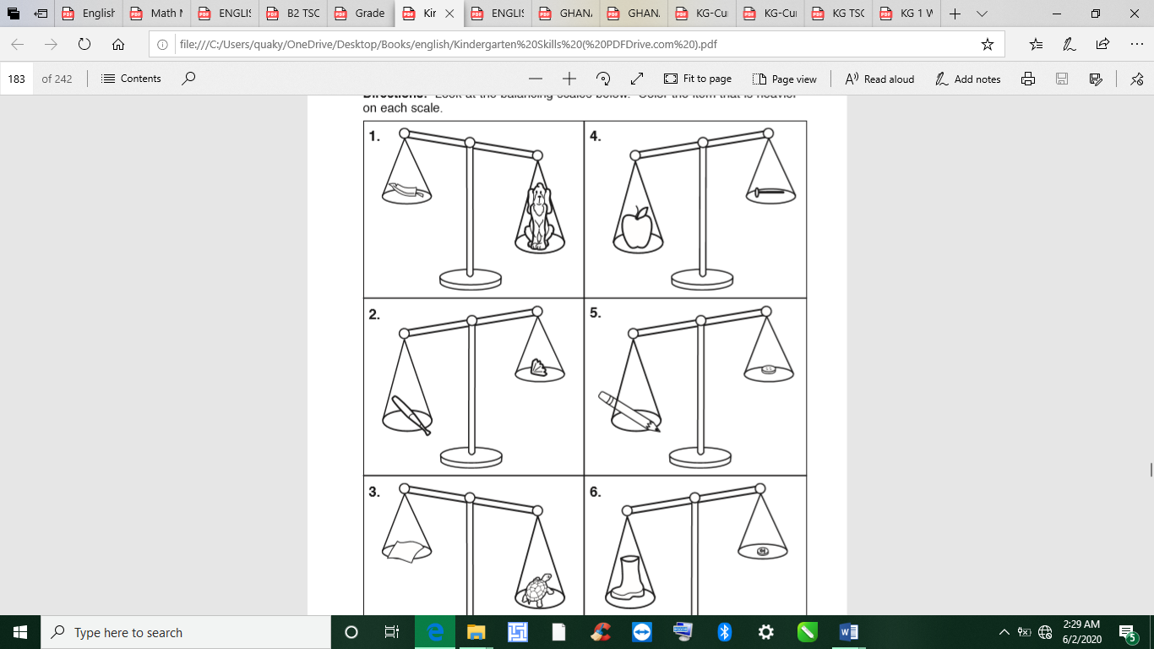  Using bottle tops or other countable objects, guide learners to pick and count the number of objects in each category.  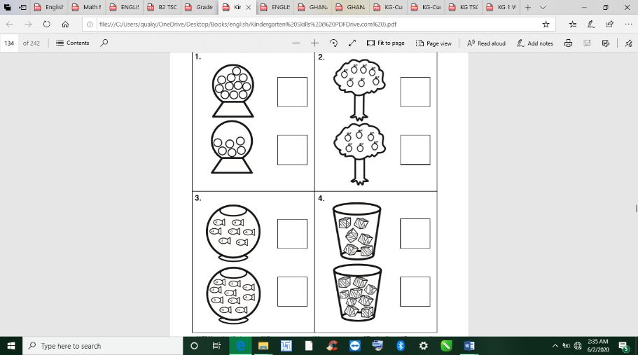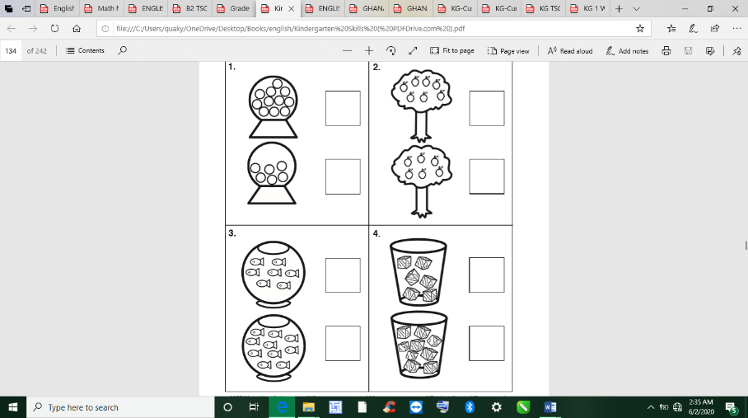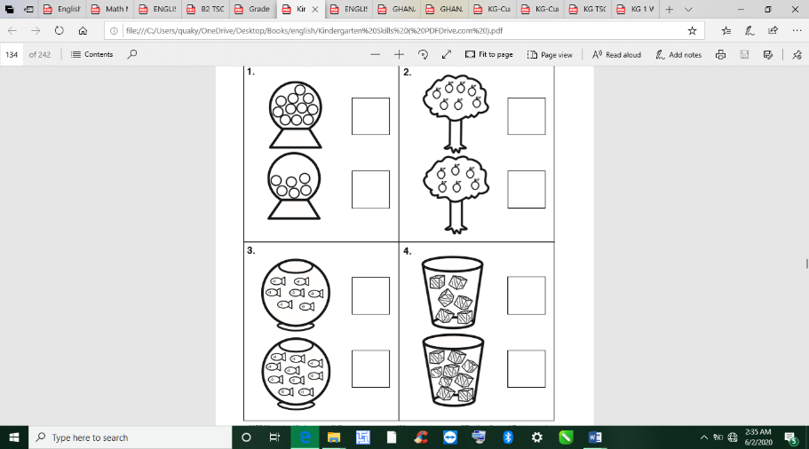  Pick the numeral card which matches with the number of objects.
LEARNING CENTER | Engage learners to play freely at the learning centers.  Observe, join in and ask learners questions frequently to guide their play and to support their understanding in what they are learning. |  |  |  |  | Learning center
STORY SHARING | Tell learners a story.  Pause regularly and ask questions to make sure learners are following.  Engage learners to act parts of the story.  1. Was the story interesting?  2. What part of the story did you like?  3. what have you learnt from the story? |  |  |  |  | Word cards, letter cards.
PHASE 3: REFLECTION | Learners share what they have learnt with their peers and class.  Give learners homework to do at home.

Date: |  | Day: THURSDAY |  |  | Strand: All Around Us
 |  |  |  |  | Sub Strand: AIR
Class: KG 2 |  |  | Class Size:
Content Standard:  K2.6.4.1 Demonstrate understanding that air is all around us and it is an important and beneficial natural resource for all living things. |  |  |  | Indicator:  K2.6.4.1.2 use a variety of new vocabulary learnt about importance of air to create an informational text for reading using learners  K2.6.4.1.3 participate actively in the teacher-read-aloud of the text on Air  K2.6.4.1.4 recognize and read 25% of sight words instantly and automatically
Performance Indicator:  - Learners can use a variety of new vocabulary learnt about importance of air to create an informational text for reading using learners  - Learners can participate actively in the teacher-read-aloud of the text on Air |  |  |  |  | Core Competencies:  Communication and collaboration, Critical thinking, Personal Development and Leadership
Keywords: Weather, rainforest, bubbles
Reference : KG Curriculum P.g. 166-169
Phase/Duration | Learners Activities |  |  |  |  | Resources
PHASE 1: STARTER | Let learners sing a song in relation to the lesson.  1. Did you enjoy the song?  2. What words did you hear in the song?
PHASE 2: NEW LEARNING  CIRCLE TIME | Choose a special calendar date such as a holiday or your child’s birthday.  Help your child count the number of days until the special event.  Cut out this number of paper strips. Make sure to add one for the special day.  Label the special-day strip and number the rest in ascending order beginning with 1.  Show your child how to make chain links by looping the special-day strip to form a ring, then gluing or taping the ends together.  Select the strip labelled 1 and run it through the special-day link before taping the ends together.  Continue connecting the numbered strips in ascending order.  Have your child remove the highest-numbered link each day by tearing the strip in half. He will always know how many days remain until the special
GROUP ACTIVITY 1  (OUTDOOR) | Display pictures/posters for learners to talk about them. Have learners talk about the pictures in pairs.  Write the keywords on the board and use illustrations in the form of pictures to explain the words to learners. air, balloon, presence, bubbles,  Ask leading questions for learners to create and dictate simple sentences orally for you to ask as a scribe to write he story for them.  e.g.  1. Where is air?  2. What can air do?  3. What comes out when a bottle is filled with water?  Write their sentences boldly on a manila card, give a heading and hang it in the classroom to be used as a text for the week.  1. Air is everywhere.  2. Air can blow leaves.  3. Kites can fly because of air.  4. We breathe in air always.  5. Plants need air to grow  Assessment  Put learners into groups of four. Let them read through the story they have created in turns. |  |  |  |  | The big book, crayons, pencils, pictures and videos depicting the uses of air. Word cards, sentence cards
PHONICS | Engage learners to sing songs and recite some familiar rhymes that relates to the target sound.  Guide learners to pronounce and write the target sound in the sand tray or exercise books.  Have learners say three or four words that contain the target sound.  Using flash cards, learners read words that contain the target sound.  1. What sound have we learnt today?  2. Which other letter sound do you know?  3. Mention any object in the classroom or home that begins with the target letter sound. |  |  |  |  | Word cards, letter cards.
GROUP ACTIVITY 2  (INDOOR) | Revise reading the sight words with learners e.g. go, to, in the, come, on, can. Divide the class into groups of five.  Give out the sight words cards for learners to practice reading in their groups.  Play: “Ladder sight words game” Draw a grid and write common sight words on the floor in the classroom or outside.  good the In boy  sister dad Come air  to o Mom girl  in he She water  Divide the class into four groups (depending on the number of learners in your class).  Read the sight word aloud and call on the groups to send a learner to hop on the word on the floor and read it aloud. If the learner is correct, the group gets a point. If nobody gets it correct, demonstrate and hop on the grid. No one get a point  Assessment  Put learners in groups of five. Give each group eight sight words cards for learners to read them  Using the Language Experience Approach (LEA), create an informational text on Air as important.  Learners observe the conversational poster on the “Weather” and “Rainforest” and with leading questions, have them create and dictate simple sentences orally and the teacher should act as a scribe to write the story for them on a big sheet and use that as a reading text throughout the week.  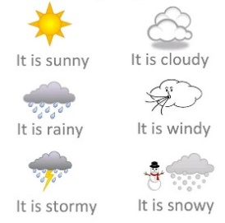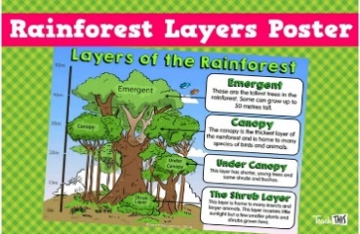  Teacher can add few sentences. Give the text a title. Ask learners to add illustrations to the text.  Teacher follows the steps of the KWL strategy instruction in reading aloud the informational text entitled AIR is all around us).  Have learners perform some simple activities showing that air is all around us
LEARNING CENTER | Engage learners to play freely at the learning centers.  Observe, join in and ask learners questions frequently to guide their play and to support their understanding in what they are learning. |  |  |  |  | Learning center
STORY SHARING | Tell learners a story.  Pause regularly and ask questions to make sure learners are following.  Engage learners to act parts of the story.  1. Was the story interesting?  2. What part of the story did you like?  3. what have you learnt from the story? |  |  |  |  | Word cards, letter cards.
PHASE 3: REFLECTION | Learners share what they have learnt with their peers and class.  Give learners homework to do at home.

